LECOINTE
LÉON AIMÉ JOACHIM

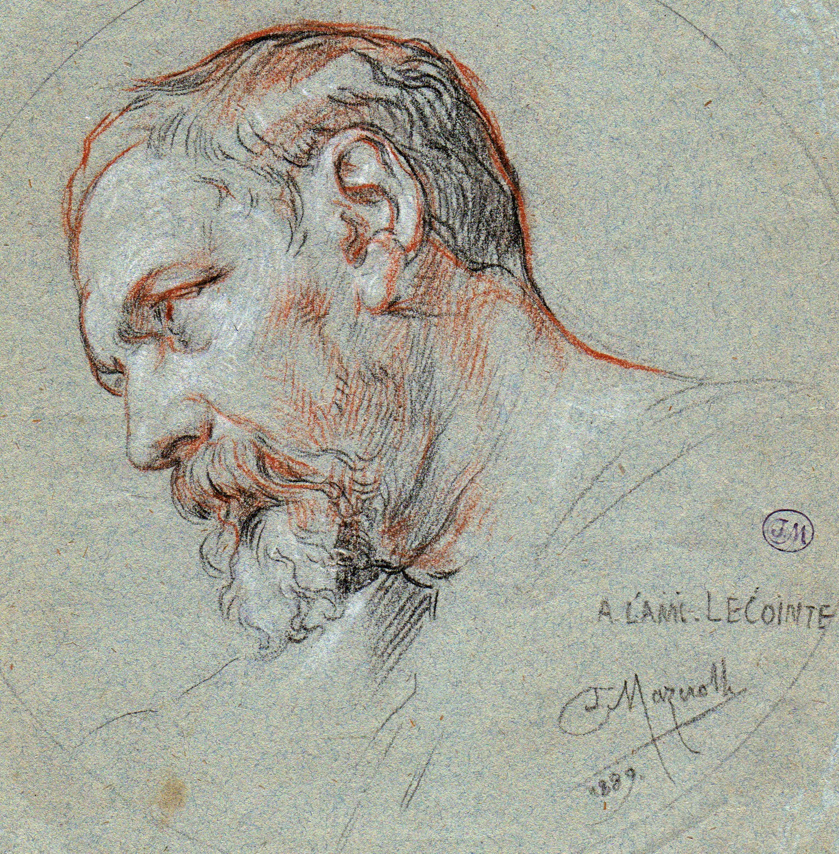
Born and died in Paris France (1826-1913).
Influenced by Klagmann et Toussaint ; Exposed at the Salon of 1850 to 1899. Member of the Committee of the Association of artists founded by the Baron Taylor since 1887. Recieved the Third class medallion in 1882 and the Bronze medal at the World Expo of 1889.

His sculptures of Diderot and Sedaine, are placed in the Square D'Anvers at Paris.
Works of art, made by Gasne of founded steel the art foundry at Tusey in Meuse and by Capitain-Gény Bussy-Vecqueville in Haute-Marne which was exposed
in the Fair of 1882.

LECOINTE, LÉON AIMÉ JOACHIM

French sculptor born in Paris, April 9 1826.
French student of Klagamann and of Toussaint, first exposed his work at the Fair in 1850. recieved the following honours: Decoration of St John the Baptist, Honourable mention in 1882
Bronze Medal at Fair in America, 1889
Extracted from dictionary of painters, sculptures,
engravers, and artists by E. Benezit in the 1924
Edition of Grande Editors of Paris.

History of the Family Lecointe
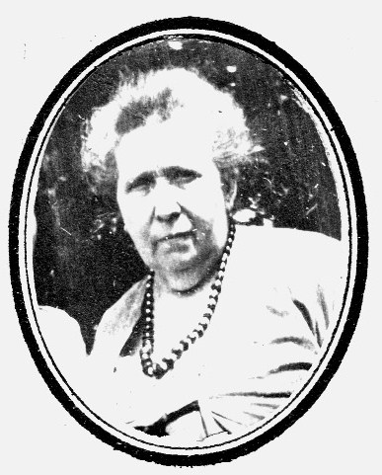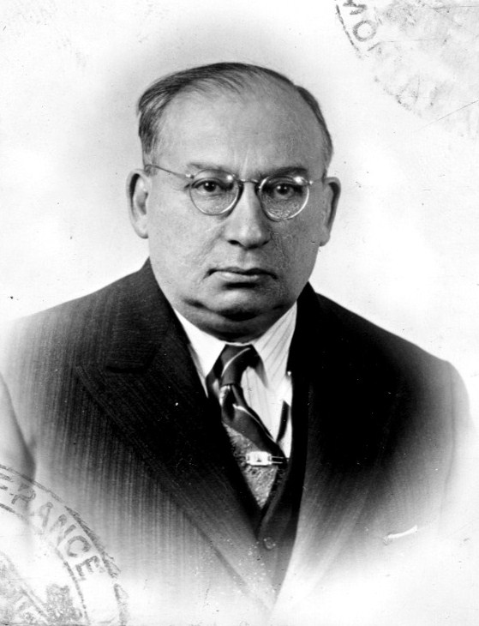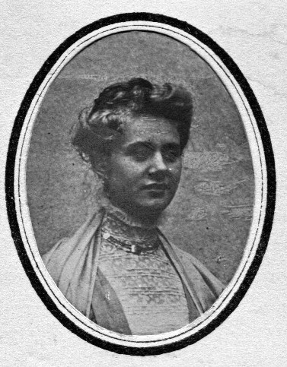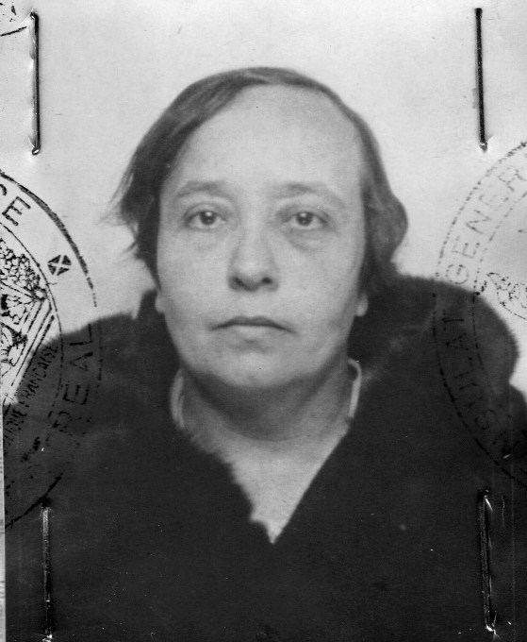
Valentine Dunand Pierre Léon Paul Marie Adélaïde Germaine Lecointe

Sculpture Mr Léon Aime Joachim, married Madame Valentine Dunand, and they had three children.
First child was Pierre Léon Paul, born in Paris, May 7 1882
Second child was Marie Adelaide Marguerite, born Paris in 1887
The third child was Germaine Andrée Emilie, born in Paris
(8th round) on March 22 1895.
Léon Aime Joachim was thirty years older than Valentine.
He died in 1913.
His Son Pierre Léon Paul Lecointe MLE 013354
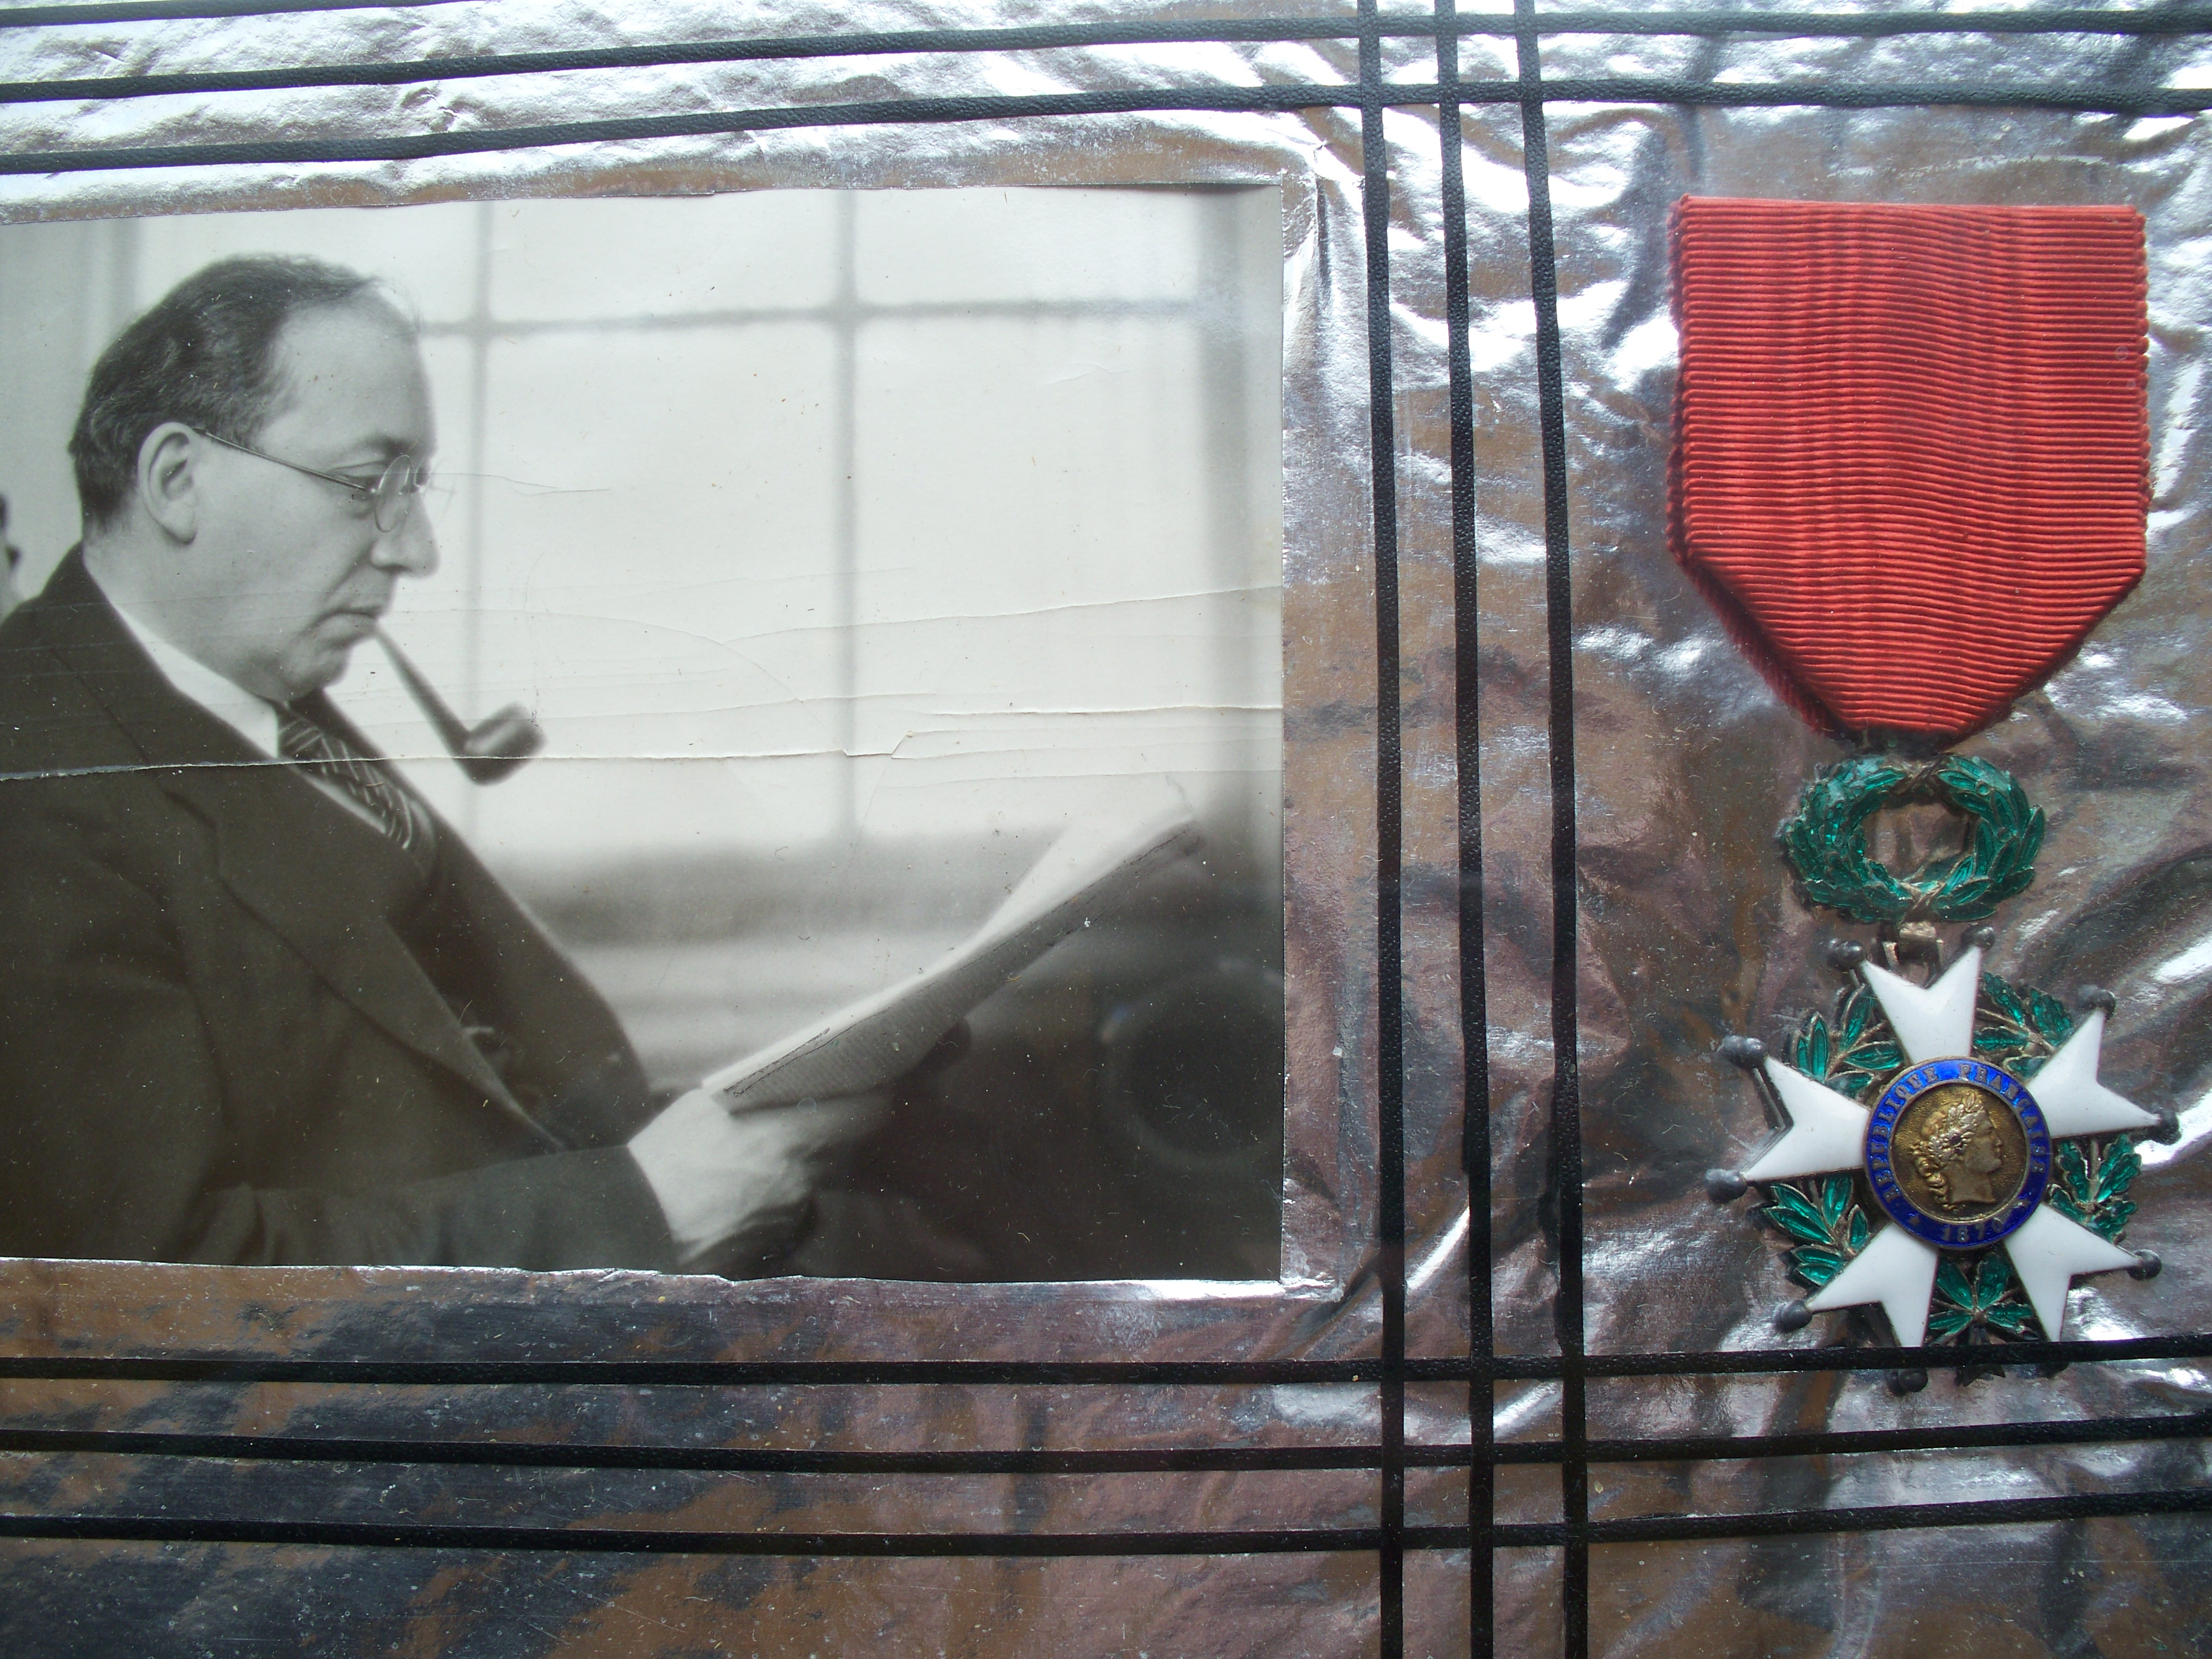
The name of M. Lecointe Pierre Léon Paul, Class of 1902, Corporal of the 46th Infantry Regiment, is inscribed the Gold Book
of the Soldiers of Verdun.

5th Region Fontaine Bleau

Extracted from the Order of the Regiment, no 10 of January 22 1916. The Chief of the Provisionary Batallion of the Regiment,
by order of the Regiment, the following soldier;
The devoted Corporal Aid Pierre Léon Paul Lecointe
distinguished himself on several occasins, by his cold bloodednes and courage, always volounteering for the more difficult and perilous mission, was seriously injured, he stood up at the line of fire, alone, under a violent bombardement, he replaced a wounded man in order to lead his team.

Republic of France

Was named Officer of the Paris Academy on Jan 30 1924.
Rec's the Medal of the Military, January 11, 1925.
Named the Chancellor of the Order of the Black Star on Sept 25, 1936. Rec's the National Order of the Legion of Honour by the President of the Republic of France and named Pierre Léon Paul Lecointe Council of Engineers for the City of Montreal.
Appointed to the Legion of Honour on July 29, 1937.
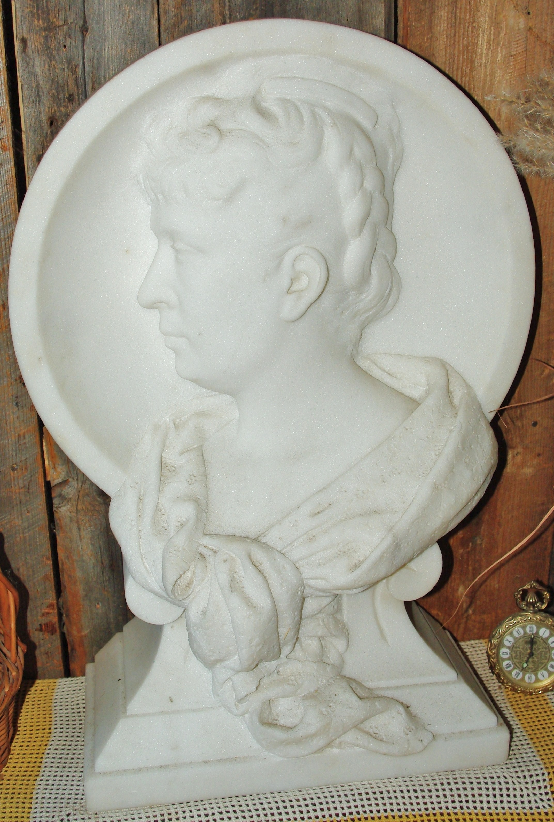

The History of this Cameo
was created in 1895.

His first daughter: In 1909, Marie Adelaide Marguerite Andrée,
fell very ill and died at age of 22
of an unknown illness.
Her father the sculptor Léon Aimé Joachim sometime earlier had a brilliant idea to make a sculpture in white marble from France, with an amazing resemblance to a cameo of his adored daughter, and his other daughter Germaine Lecointe, who inherited
this treasure.

And the History Continues...

Around 1920, Pierre Léon Paul Lecointe, Engineer Council, moved to Montreal with his mother Valentine Dunand, and was a professor at the Polytecnique of Montreal. His mother died on January 3rd 1931 in Montreal at the age of 72.
In 1937, there is talk of war in Europe, and Germaine also decides to come and establish herself in Montreal. She brought with her this wooden case and this precious heritage sculpture.

Having arrived in Montreal on the 22nd of October 1937, a good seemstress, she becomes friends with the sister of my mother (Marguerite Deneault Petit), Jeanne Deneault, who owned a boutique on Garnier Street in Montreal. Auntie Jeanne has a very
fussy clientelle, hires Germaine Lecointe, and together they become very close friends.

PARIS 1900

This work of art created by Léon Aimé Joachim Lecointe, was entered into the World Fair of Paris in 1900, and won first prize in it's catagory which was Hors Concours Expert du Jury. This special crate, which it is today kept in, was used at that competition in Paris. The same crate brought it to Montreal.

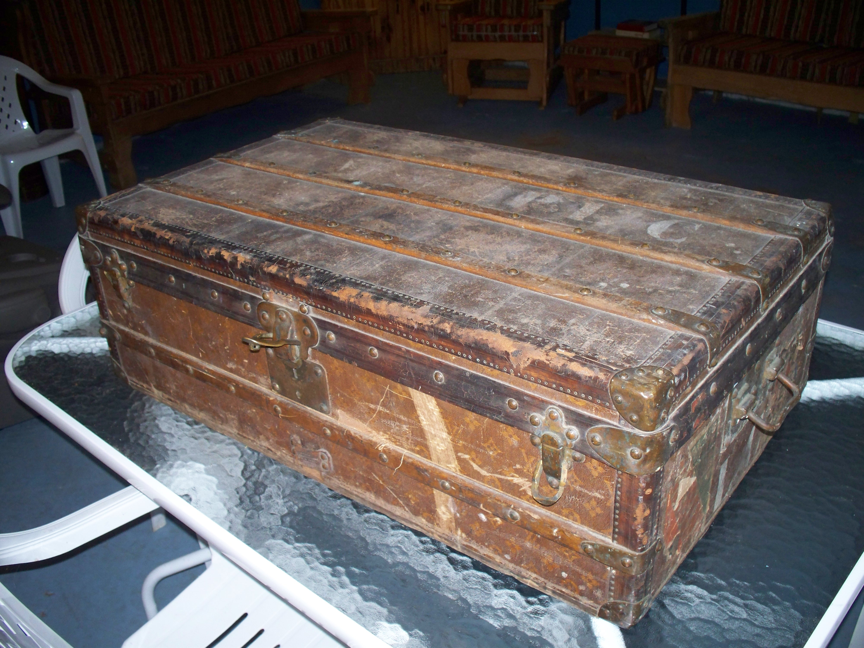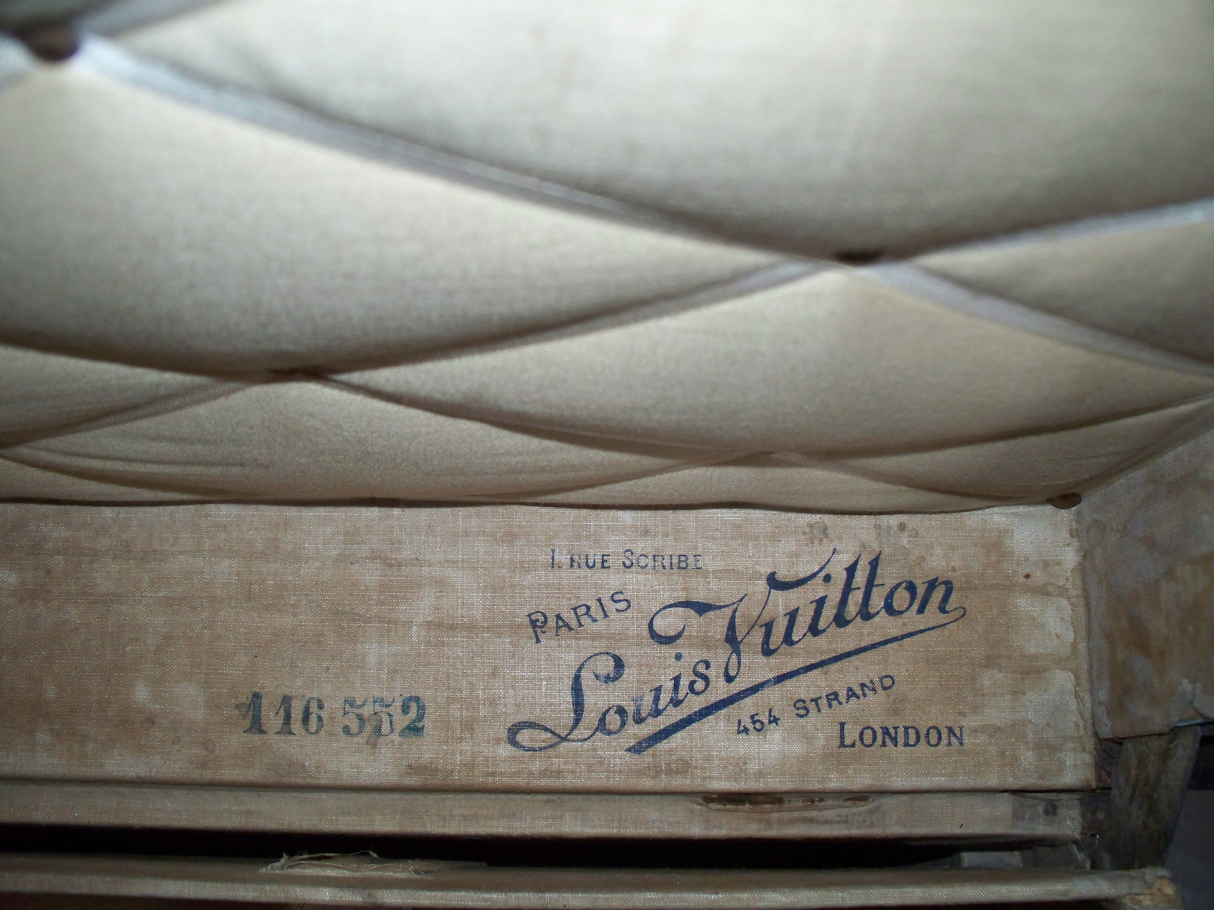

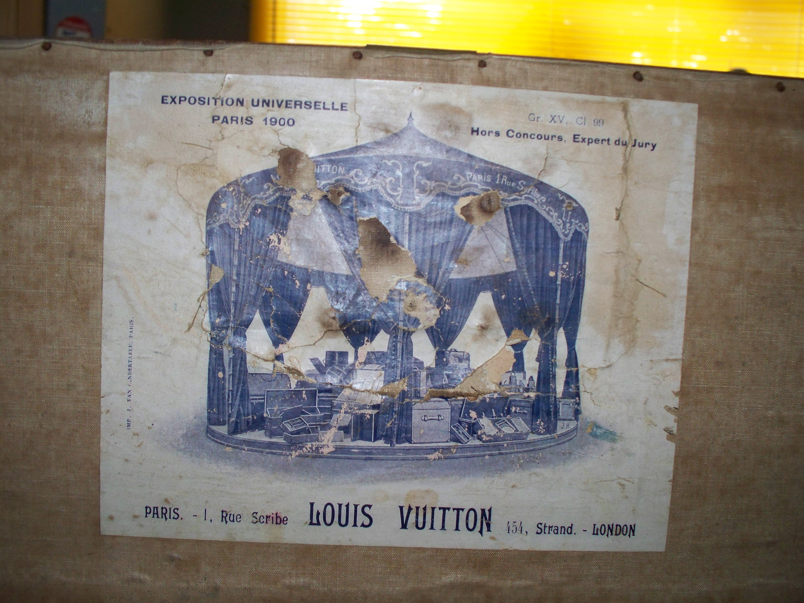


Auntie Jeanne's Favorite
And of Germain's too!

For 35 years, i have this sculpture in
St. Jean de Matha in Lanaudiere Region of Quebec Canada. When I was almost 15 years of age, wen i first met Mrs. Germaine Lecointe, she was very kind to me and often brought me gifts. I always admired this beautiful white Cameo Sculpture that her father had made of her sister's likeness. She often told me the entire story of the sculpture, and a few weeks before she died, she asked my auntie Jeanne, to give this sculpture to me, in rememberance of her.
Émilie Andrée Germaine Lecointe would have been 115 years old on the 22nd of March 2010. This work of sculptural art was inherited, researched, and documented as totally original by
Bob Petit, the current owner, son of Marguerite Deneault Petit and his father Ferdinand Petit of Montreal.
Email bob.petit2@ sympatico.ca www.bobpetit.ca
Cell 450 803-2985

